Ucoopia: Europe’s very first inter-university NGO, “a groundbreaking and unique association that demonstrates the strength and dynamism of cooperation”
Increasing the scope and effectiveness of cooperation initiatives: this is the stated aim of Ucoopia, Europe’s very first inter-university NGO. It is the result of a partnership between ULB-Coopération, the NGO of the Université libre de Bruxelles, and Eclosio, the NGO of the University of Liège, with the support of their parent universities and the University of Mons.

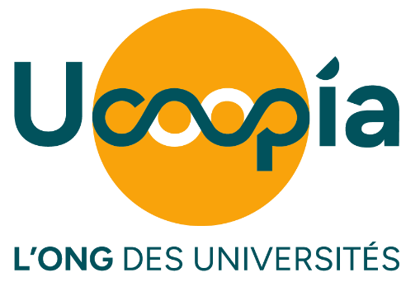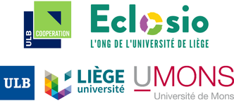

The decision has been made: from January 2026, the NGOs of the universities of Brussels and Liège will join forces. The general assemblies of the two non-profit organisations formally approved the merger on 25 June, following several months of preparation carried out in partnership with their parent universities and the University of Mons.
“In the current climate of significant pressure on public funding for cooperation, the union of our two NGOs, which share a common vision and a university DNA, will bring real added value to our projects,” says Patrick Wautelet, professor of law at ULiège and president of Eclosio.
Serge Jaumain, advisor to the Rector of the ULB on Cooperation and president of ULB-Cooperation, is equally enthusiastic: “Ucoopia opens a new chapter in the history of NGOs. It is a groundbreaking association, unique in Europe, which illustrates the strength and dynamism of academic cooperation within the Wallonia-Brussels Federation and paves the way for the cooperation of tomorrow.”
The University of Mons has, in fact, already committed to the new structure. “UMONS is enthusiastic and proud to join the inter-university NGO Ucoopia, an essential extension of the university’s commitment to society,” says Laurence Ris, Vice-Rector for International Relations, Mobility and Cooperation at the university.
As Europe’s first inter-university NGO, Ucoopia has set itself a mission: to build bridges between knowledge. Building on the work of its two founding NGOs, it will bring together academic communities, local populations and public institutions around projects that address tangible issues in health, the environment, education and employment in an innovative and sustainable manner. “Ucoopia embodies what the ULB has always stood for: free thought, critical scholarship and a concrete commitment to greater social justice,” emphasises Anne Weyembergh, Vice-Rector for External Relations and International Cooperation at the ULB.
Ucoopia aims to become a benchmark in Belgium and beyond. Active in Latin America, Europe, West, Central and Southern Africa, as well as in Asia, Ucoopia will bring together not only the universities of Brussels, Liège and Mons, but also other higher education institutions, both in the North and the South.
The future director of Ucoopia, Julie Simon, announces this with conviction:
“Ucoopia opens up new horizons: those of an even more effective, even more committed and even more innovative university NGO!” She is keen, however, to reassure everyone: “For the time being, nothing is changing within the two organisations set to merge. Ongoing projects will continue with the same commitment to our beneficiaries and local partners.”

For any enquiries: Julie Simon, Deputy Director of ULB-Coopération and future Director of Ucoopia - julie.simon@ulb-cooperation.org - 0474 364 020
For interview requests: com@ucoopia.org
Further information: https://ucoopia.org/en/
ULB-Coopération
ULB-Coopération is the NGO of the Université libre de Bruxelles. Its activities are based in Burkina Faso, the Democratic Republic of the Congo, Senegal and Belgium. It is active in four key areas: health & health systems, territories & resources, management & entrepreneurship, and education & critical citizenship. Through each of these areas, the aim is to improve people’s living conditions – socially, environmentally and financially – by co-developing projects with all stakeholders.
More info: https://www.ulb-cooperation.org/

Eclosio
Eclosio is the University of Liège’s NGO. It works in Benin, Senegal, Guinea, Cambodia, Peru, Bolivia and Belgium, focusing on three key areas: agroecological transition, the socio-economic integration of communities, and civic engagement in response to societal and climate challenges.
Through its work, Eclosio aims for a world where current and future generations can together exercise their right to live with dignity, in harmony with their environment.
More info: https://www.eclosio.ong/

